Homework for week 2, submission deadline 23:59 on Sunday night.
- Choose your own topics from following list or your own.
- Gut microbiota and metabolic disease
- Single-cell transcriptomics in cancer immunology
- Antibiotic resistance genomics
- Epigenetic regulation in neurological disorders
- Muscle regeneration and aging
- Proteomic biomarkers in MAFLD/MASH
Finish the following question section we covered in the class
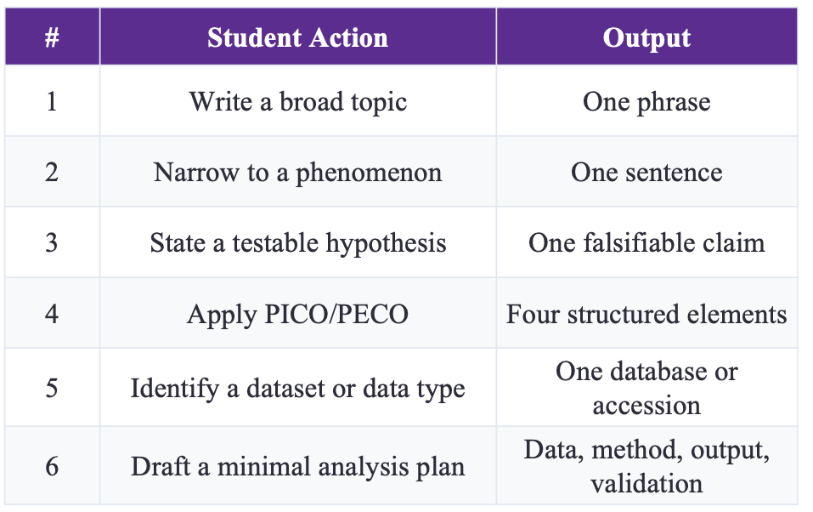
1. Broad topic | Gut microbiota and metabolic diseases, particularly obesity and glucose metabolism.
2. Narrow phenomenon | Butyrate-producing gut microbial taxa and butyrate-synthesis pathways may be reduced in adults with type 2 diabetes (T2D)
3. Testable hypothesis | Adults with T2D have lower relative abundance of butyrate-producing taxa and lower butyrate-synthesis pathway abundance than non-diabetic controls after adjustment for age, sex, BMI, diet, medication use, sequencing batch, and sequencing depth.
4. Apply PECO | P — Population: Adults in a human stool metagenomic cohort with available T2D status and relevant clinical metadata.  E — Exposure: Type 2 diabetes (T2D) status.  C — Comparison: Adults without T2D from the same or a comparable cohort.  O — Outcome: Relative abundance of butyrate-producing microbial taxa and abundance of microbial pathways involved in butyrate biosynthesis.
5. Dataset/data type | A human stool shotgun metagenomic dataset containing T2D status and relevant clinical metadata, including age, sex, BMI, diet, medication use, sequencing batch, and sequencing depth. An independent cohort with comparable variables would be used for external validation if available.
6. Minimal analysis plan | Data: Include adults with valid T2D status, adequate sequencing quality, and available core covariates. Compare T2D with non-T2D adults. Exclude participants with recent antibiotic exposure if this information is available.  Method: Perform taxonomic and functional pathway profiling, followed by covariate-adjusted regression models. Adjust for age, sex, BMI, diet, medication use, sequencing batch, and sequencing depth as appropriate. Apply false discovery rate (FDR) correction for multiple testing.  Output: Report adjusted effect sizes, 95% confidence intervals, and FDR-adjusted P values. Summarize the main results using forest plots and heatmaps.  Validation: Repeat the analysis in an independent cohort if available and perform sensitivity analyses, particularly after excluding metformin users.

- Find and read two research papers in the folder and answer following question based on these two papers.
  - Question 1: Use the PICO/PECO, what are they for these two papers?
  - Question 2: What kind of dataset or data type these two papers use?
  - Question 3: What is the hypothesis of these two research?
Paper title
Microbial network signatures of early colonizers in infants with eczema
Question 1
P — Population:
Full-term, vaginally delivered infants from mother–infant pairs in Guangzhou, China, followed from birth to 6 months of age. The final analysis included 34 infants.
E — Exposure:
Development of infantile eczema by 6 months of age.
C — Comparison:
Infants who did not develop eczema by 6 months of age.
O — Outcome:
Differences in early-life gut microbiota diversity, community structure, microbial network complexity, and network stability during the first three months of life.
Question 2
The study used longitudinal infant microbiome data generated by 16S rRNA gene amplicon sequencing. Meconium was collected at birth, followed by fecal samples at 1, 2, and 3 months of age. The study generated ASV-based microbiome profiles and performed microbial diversity, community structure, and network analyses. Clinical metadata from mother–infant pairs were also included.
Hypothesis
The study hypothesizes that infants who develop eczema show abnormal early-life gut microbiota maturation compared with healthy infants, characterized by differences in microbial diversity, community structure, and the complexity and stability of microbial interaction networks during the first 100 days of life.
Paper title
Identification of shared and disease-specific host gene–microbiome associations across human diseases using multi-omic integration
Question 1: PECO
P — Population:
Individuals from three gastrointestinal disease cohorts with paired colonic mucosal host transcriptomic and microbiome data, including patients with colorectal cancer (CRC), inflammatory bowel disease (IBD), or irritable bowel syndrome (IBS), together with their corresponding controls.
E — Exposure:
Gastrointestinal disease status: CRC, IBD, or IBS.
C — Comparison:
Corresponding non-disease controls: patient-matched normal colon tissue for CRC, non-IBD controls for IBD, and non-IBS controls for IBS.
O — Outcome:
Disease-associated relationships between gut microbial taxa and host gene expression or biological pathways, including shared and disease-specific host gene–microbiome associations across CRC, IBD, and IBS.
Question 2
This study used paired multi-omics datasets from colonic mucosal biopsy samples, including host transcriptomic RNA-seq data and mucosal gut microbiome 16S rRNA sequencing data. In total, the study included 208 paired microbiome and host gene expression samples from CRC, IBD and IBS cohorts.
Question 3:
The study hypothesizes that host gene expression and gut microbial abundance are coordinated in gastrointestinal diseases, and that their associations include both biological patterns shared across CRC, IBD, and IBS and disease-specific patterns unique to each disease. The same host pathway may therefore be associated with different microbial taxa in different disease contexts.
- Based on your research interest, refine the search in PUBMED, and sort, identify the latest and the most important studies in your field. Read this paper and answer three questions:
  - Question 1: Use the PICO/PECO, what are they for these two papers?
  - Question 2: What kind of dataset or data type these two papers use?
  - Question 3: What is the hypothesis of these two research?
Research interest
Gut microbiome interactions with obesity and glucose metabolism.
PubMed search strategy
PubMed query:
("gut microbiome"[Title/Abstract] OR "gut microbiota"[Title/Abstract]) AND (obesity[Title/Abstract] OR "glucose metabolism"[Title/Abstract] OR "glycemic response"[Title/Abstract] OR "type 2 diabetes"[Title/Abstract]) AND Humans[MeSH Terms]
Paper title
Tian et al., 2026 — Multi-omics analysis identify novel microbiome-metabolome signatures associated with obesity.
Question 1
P — Population:
Unrelated US men aged 20–50 years with paired stool and fasting blood samples and available BMI and relevant covariate data.
E — Exposure:
Higher adiposity as measured by BMI; obesity was defined as BMI ≥30 kg/m², while BMI was also analysed as a continuous exposure.
C — Comparator:
Healthy-weight participants with BMI 18.5–24.9 kg/m² from the same discovery cohort.
O — Outcome:
BMI-associated gut microbial diversity and species abundance, serum metabolites and lipid profiles, short-chain fatty acids, and integrated microbiome–metabolome associations.
Validation:
Selected microbial associations were evaluated in an independent Chinese female cohort using BMI-based low- and high-BMI groups.
Question 2
The study used paired human multi-omics data, primarily including fecal shotgun metagenomic sequencing and fasting-serum metabolomic profiling. The metabolomic data included untargeted metabolomics, lipidomics, and targeted short-chain fatty acid measurements. Human genomic data and demographic, dietary, lifestyle, medication/supplement, and BMI information were also available as covariates. The discovery cohort consisted of 495 US men, and major microbiome findings were evaluated in an independent cohort of 498 Chinese women.
Question 3
Based on the stated aim of the study, the hypothesis is that obesity and higher BMI are associated with distinct gut microbial and serum metabolic profiles, and that some BMI-associated gut microbes are linked to obesity-related circulating metabolites, forming identifiable microbiome–metabolome signatures. Some of these microbial associations are expected to be reproducible in an independent population.

Paper title
Zeevi et al., 2015 — Personalized Nutrition by Prediction of Glycemic Responses.
Question 1
PECO — observational/prediction phase
P — Population: Adults aged 18–70 years without previously diagnosed type 2 diabetes, recruited into the main 800-person cohort and an independent 100-person validation cohort.
E — Exposure: Individual-level dietary, clinical, anthropometric, lifestyle, physical-activity and gut microbiome characteristics associated with postprandial glycemic responses.
C — Comparison: Individuals or meals with different combinations of these personal and dietary characteristics; the study also compared prediction performance against conventional carbohydrate-based prediction.
O — Outcome: Postprandial glycemic response (PPGR), quantified from continuous glucose monitoring as the 2-hour incremental area under the glucose curve after meals.
PICO — dietary intervention phase
P — Population: 26 participants enrolled in the blinded randomized dietary intervention.
I — Intervention: A personalized “good” diet composed of meals predicted by the algorithm to produce low PPGRs.
C — Comparison: A personalized “bad” diet composed of meals predicted to produce high PPGRs.
O — Outcome: Differences in postprandial glycemic responses and related glucose-control measures, together with changes in gut microbiota.
Question 2
The study used a large human multi-modal dataset including continuous glucose monitoring, detailed dietary records, anthropometric measurements, blood tests, lifestyle and medical questionnaires, physical-activity and sleep records, and gut microbiome profiles generated by both 16S rRNA and metagenomic sequencing. The main cohort included 800 participants, and an independent 100-person cohort was used for validation.
Question 3
The study hypothesizes that postprandial glycemic responses are highly individualized and cannot be adequately predicted from food composition alone. Instead, integrating person-specific clinical, lifestyle, dietary and gut microbiome features should enable accurate prediction of individual glycemic responses, and dietary recommendations based on these predictions should reduce postprandial glucose responses.

